Edward Basnet

Proposal
AC FAILURE, SMOKE DETECTION AND OVER TEMPERATURE ALARM SYSTEM

Table of Contents
A. AC FAILURE, SMOKE DETECTION AND OVER TEMPERATURE ALARM SYSTEM 3
1. General Features 3
2. Cost Estimation 3
B. REAL-TIME MONITORING AC FAILURE, SMOKE DETECTION AND OVER TEMPERATURE ALARM SYSTEM 3
1. General Features 3
2. Cost Estimation 4
Support and Services 4

- AC FAILURE, SMOKE DETECTION AND OVER TEMPERATURE ALARM SYSTEM

General Features
- Micro-controller based digital embedded system.
- High quality K-type thermocouple based temperature monitoring system.
- MQ-2 Smoke sensor Module is used for detecting any flammable condition.
- Input power: AC220V, 50/60Hz
- High quality and highly luminous LCD type display is used for displaying all the details about system.
- Loud electric siren is used for alerting.
- Designed to use for indoor only.
- High quality AC line detection circuitry is used.
- Own battery backup and charging unit.

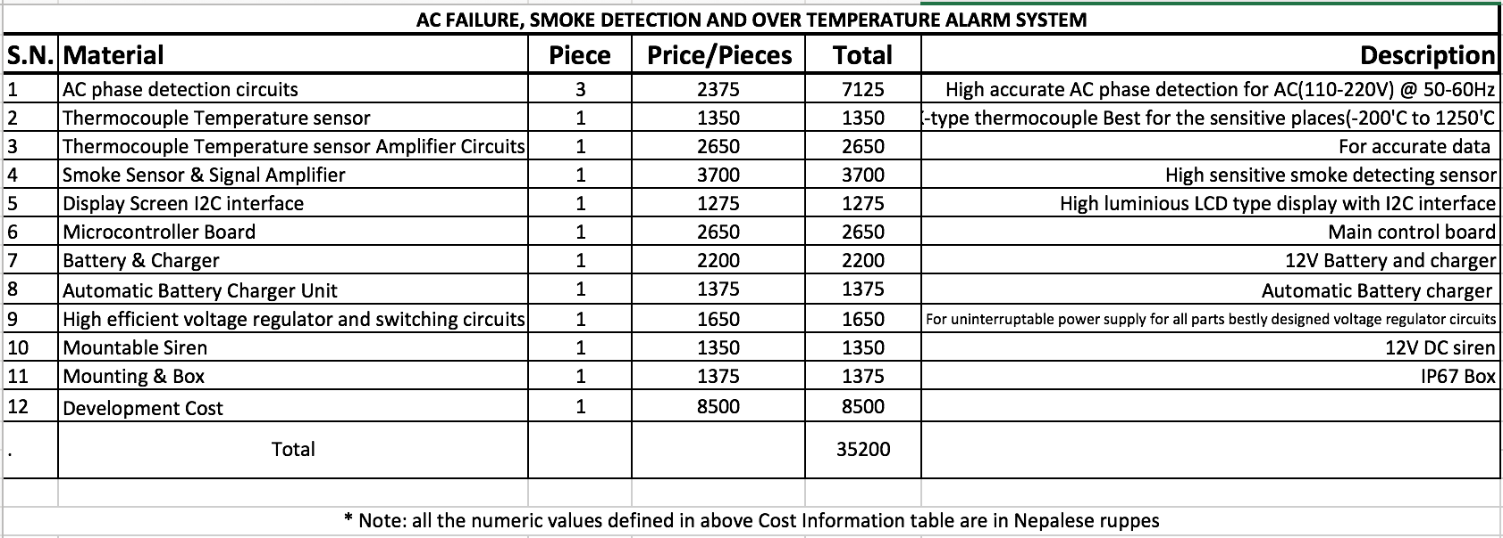
Cost Estimation

REAL-TIME MONITORING AC FAILURE, SMOKE DETECTION AND OVER TEMPERATURE ALARM SYSTEM

General Features
- Micro-controller based digital embedded system.
- High quality K-type thermocouple based temperature monitoring system.
- MQ-2 Smoke sensor Module is used for detecting any flammable condition.
- Input power: AC220V, 50/60Hz
- High quality and highly luminous LCD type display is used for displaying all the details about system.
- The whole status of the systems can be monitored and controlled from any desktop, laptop or smart phone connected to the same network. i.e. Smoke status, temperature status, AC phase online/offline status.
- Loud electric siren is used for alerting.
- Designed to use for indoor only.
- High quality AC line detection circuitry is used.
- Own battery backup and charging unit.

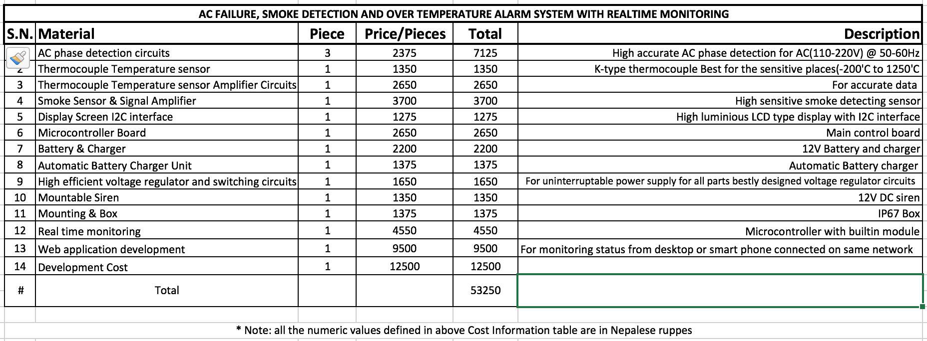
Cost Estimation

Support and Services
Half year free service will be provided from the date of installation. Developer’s party shall not be responsible for malfunctioning components.

** all the amount defined are excluding VAT

